Answers 3.3

Step: 1

By using: SELECT name FROM category, I was able to locate all 16 genres in the category table.

|  |
| --- |
| "Action" |
| "Animation" |
| "Children" |
| "Classics" |
| "Comedy" |
| "Documentary" |
| "Drama" |
| "Family" |
| "Foreign" |
| "Games" |
| "Horror" |
| "Music" |
| "New" |
| "Sci-Fi" |
| "Sports" |
| "Travel" |

Step 2:

* By using INSERT INTO category (name) VALUES ('Thriller'), ('Crime'), ('Mystery'), ('Romance'), ('War'). I was able to add those 5 genres to the name column in category.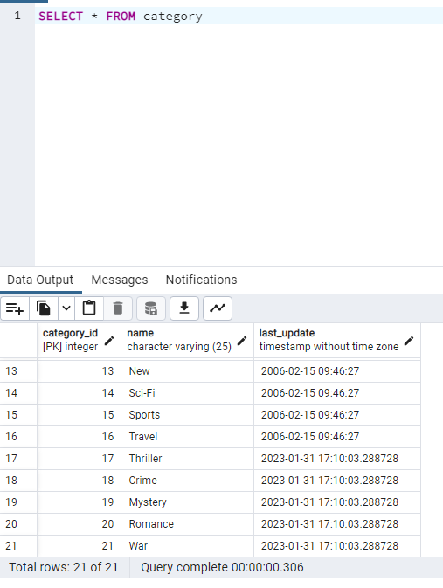
* **Write a short paragraph explaining the various constraints that have been applied to the columns. What do these constraints do exactly? Why are they important?**

**category_id integer NOT NULL DEFAULT nextval('category_category_id_seq' ::regclass),**

**name text COLLATE pg_catalog."default" NOT NULL,**

**last_update timestamp with time zone NOT NULL DEFAULT now(),**

**CONSTRAINT category_pkey PRIMARY KEY (category_id)**

**Explanation:**

NOT NULL DEFAULT: These constraint prevent null values and empty cells in these columns.

PRIMARY KEY: gives category_id a unique ID.

Step 3:

* **Write the SELECT statement to find the film_id for the movie African Egg.**

SELECT film_id FROM film WHERE title = 'African Egg'. This gives us 5 as the film_id for African Egg.

SELECT film_id, category_id FROM film_category WHERE film_id = 5. This gives us category_id of 8.

Film_id is 5 & category_id is 8.

* **Once you have the film_ID and category_ID, write an UPDATE command to change the category in the film_category table (not the category table). Copy-paste this command into your answers document.**

By running SELECT category_id, name FROM category, we can see that the Thriller Id is 17 which gives us the last piece we need in order to makes these changes.

UPDATE film_category

SET category_id = 17

WHERE film_id = 5

**Step 4:**

**Since there aren’t many movies in the mystery category, you and your manager decide to remove it from the category table. Write a DELETE command to do so and copy-paste it into your answers document.**

DELETE FROM category WHERE name = 'Mystery'

**Step 5:**

**Based on what you’ve learned so far, think about what it would be like to complete steps 1 to 4 with Excel instead of SQL. Are there any pros and cons to using SQL? Write a paragraph explaining your answer.**

Many of these steps would need to be completed manually in excel and may take an absurd amount of time. However, being familiar with excel makes it easier to navigate. Like any language SQL has a learning curve that doesn’t allow for speedy results.